|  |
| --- |
|  |
| The Documentation |
| [Type the document subtitle] |
|  |
| **[Your Name]** |
| **[Pick the date]** |

[Type the abstract of the document here. The abstract is typically a short summary of the contents of the document. Type the abstract of the document here. The abstract is typically a short summary of the contents of the document.]

Table of Contents

[To update the table of contents, right click the message below and select Update Field (F9 on PC, ⌥⌘U on Mac).]

**No table of contents entries found.**

1. Pages
   1. Page Tree

Splash Screen  
Log In  
Sign Up  
Home  
Search  
Ticket details  
Ticket purchesed  
Chatbox

* 1. Splash Screen
     1. User Interface

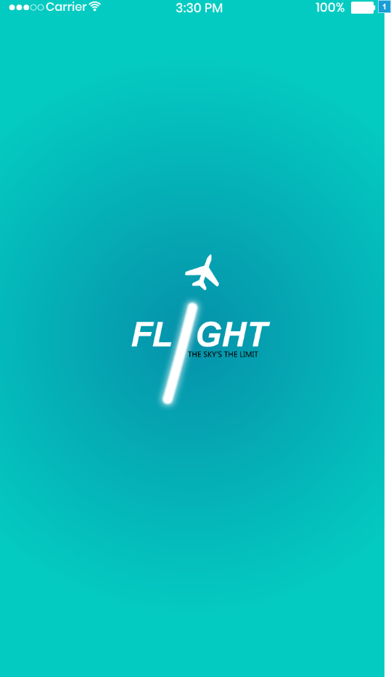

* + 1. Widget Table

| Footnote | Interactions |
| --- | --- |
| 1 | OnMouseEnter:  Case 1:  Wait 2000 ms  Open Log In in Current Window |

* 1. Log In
     1. User Interface

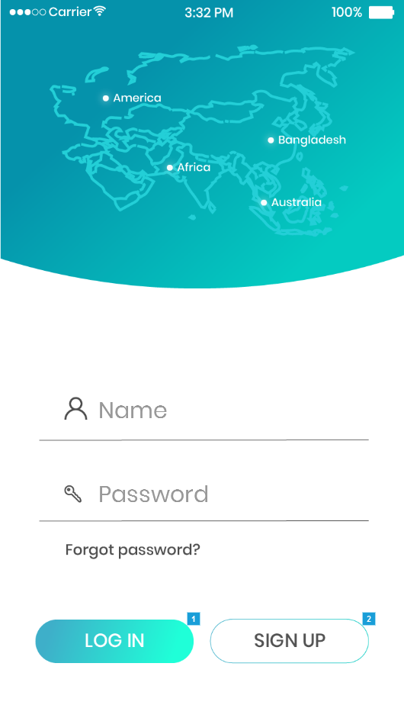

* + 1. Widget Table

| Footnote | Name | Interactions |
| --- | --- | --- |
| 1 | log in | OnClick:  Case 1:  Open Home in Current Window |
| 2 | sign up | OnClick:  Case 1:  Open Sign Up in Current Window |

* 1. Sign Up
     1. User Interface

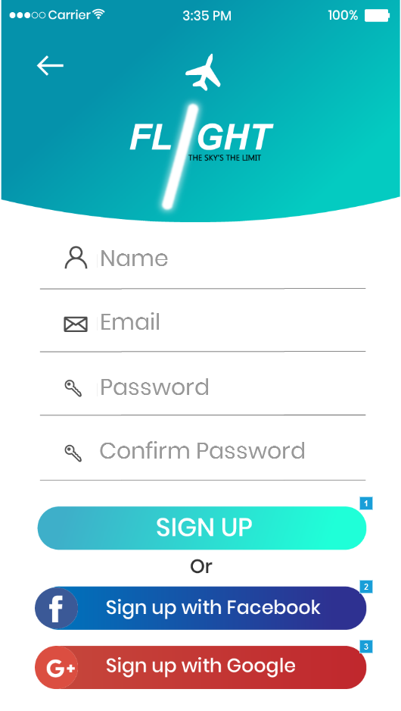

* + 1. Widget Table

| Footnote | Interactions |
| --- | --- |
| 1 | OnClick:  Case 1:  Open Home in Current Window |
| 2 | OnClick:  Case 1:  Move (Image) by (380,0) linear 500ms  Wait 1000 ms  Open Home in Current Window |
| 3 | OnClick:  Case 1:  Move (Image) by (380,0) linear 500ms  Wait 1000 ms  Open Home in Current Window |

* 1. Home
     1. User Interface

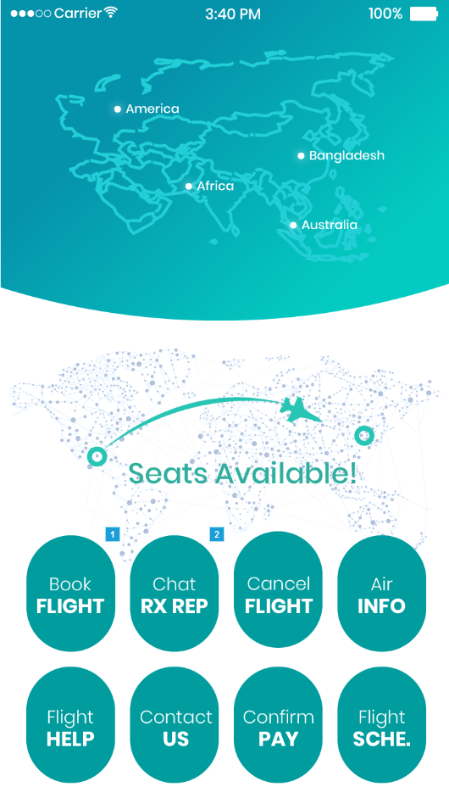

* + 1. Widget Table

| Footnote | Interactions |
| --- | --- |
| 1 | OnClick:  Case 1:  Open Search in Current Window |
| 2 | OnClick:  Case 1:  Open Chatbox in Current Window |

* 1. Search
     1. User Interface

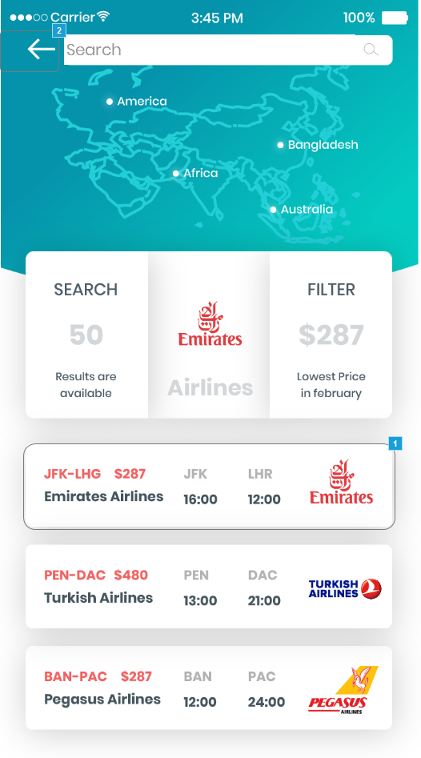

* + 1. Widget Table

| Footnote | Interactions |
| --- | --- |
| 1 | OnClick:  Case 1:  Open Ticket details in Current Window |
| 2 | OnClick:  Case 1:  Open Home in Current Window |

* 1. Ticket details
     1. User Interface

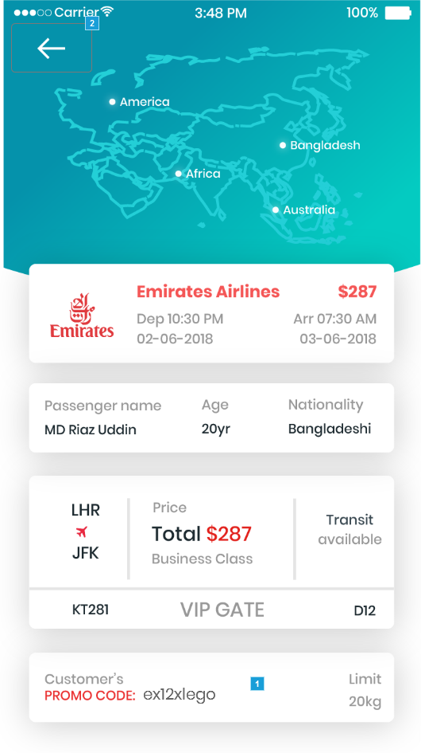

* + 1. Widget Table

| Footnote | Interactions |
| --- | --- |
| 1 | OnLostFocus:  Case 1:  Open Ticket purchesed in Current Window |
| 2 | OnClick:  Case 1:  Open Search in Current Window |

* 1. Ticket purchesed
     1. User Interface

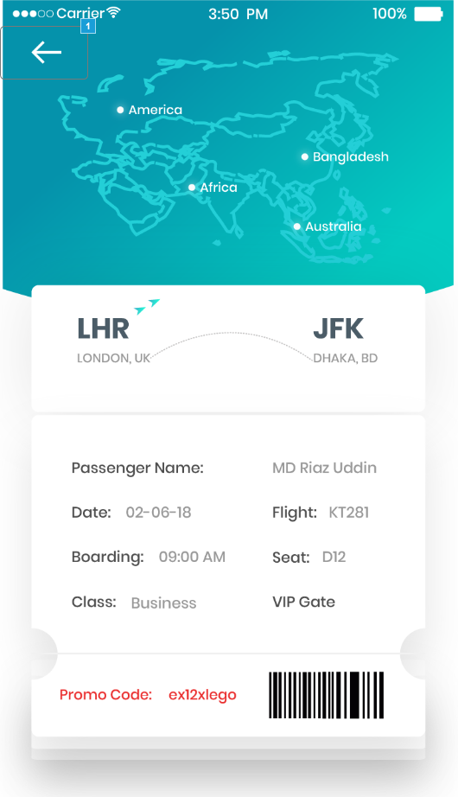

* + 1. Widget Table

| Footnote | Interactions |
| --- | --- |
| 1 | OnClick:  Case 1:  Open Home in Current Window |

* 1. Chatbox
     1. User Interface

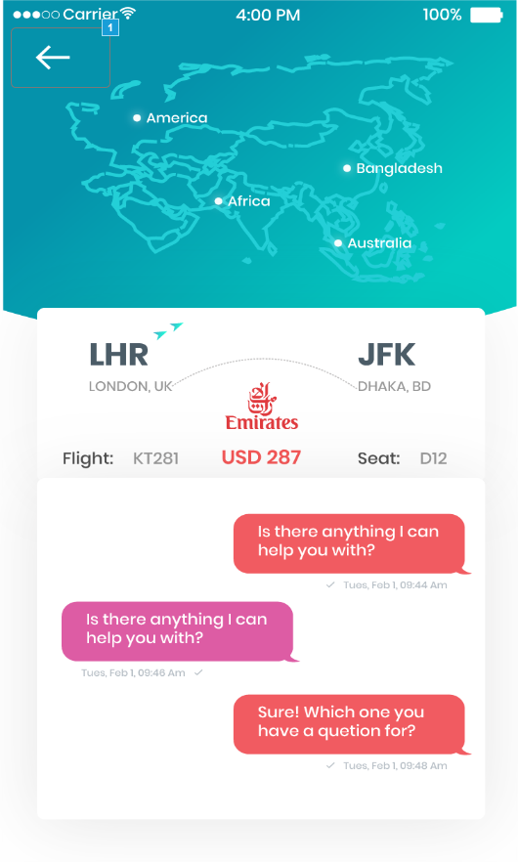

* + 1. Widget Table

| Footnote | Interactions |
| --- | --- |
| 1 | OnClick:  Case 1:  Open Home in Current Window |